Psychological statistics
Homework Assignment ①
B812109041 Isaac, Lee

- PROBABILITY
- A standard normally distributed variable is larger than 3.
Function: pnorm(), Calculate Cumulative distribution functions (CDF).
Larger than 3: 1 - pnorm(3)
Ans: 0.0013498980316301
- R code
# PROBABILITY (a)
probability_a <- 1 - pnorm(3)
print(probability_a)
- A normally distributed variable with mean 35 and standard deviation 6 is larger than 42.
Function: pnorm (x, mean, sd)
Larger than 42: 1 - pnorm(42,35,6)
Ans: 0.121672504574381
- R code
# PROBABILITY (b)
# pnorm(x, mean, sd)
probability_b <- 1 - pnorm(42,35,6)
print(probability_b)
- Getting 10 out of 10 successes in a binomial distribution with probability 0.8.
Function: dbinom(x, size, prob), Calculate Probability Mass Function (PMF).
Ans: 0.1073741824
  - R code
# PROBABILITY (c)
# dbinom(x, size, prob)
probability_c <- dbinom(10,10,0.8)
print(probability_c)
- INFIDELITY
    - Restructure the data by merging "Self" and "Partner" into a new column called "Target", and add a new column called "Score" to record the number of bullets, facilitating the subsequent creation of statistical plots.
    - Utilize the library (dplyr) to group the data and calculate the mean and standard deviation for each group, facilitating the creation of error bars. Group the data by "Gender" and "Target" to form four groups (e.g., Male+Self).
    - Plot the data using a bar chart with error bars to display the differences in the number of bullets used between different genders.
    - Result:
From the graph, it can be observed that females have the highest number of bullets used on "Self", significantly surpassing the number used by males on "Self". The maximum value even reaches 100 bullets solely used on "Self".
On the contrary, the situation for males is exactly opposite. The number of bullets used on "Partner" by males exceeds that used on "Self", with the average being similar to females' usage on "Partner". Additionally, the overall bullet usage by males is notably less than that by females. This graph, grouped by gender, yields intriguing results.
It's evident that there are significant differences between males and females. However, the sample size for each group is only 12 individuals. If we could increase the sample size, the results presented would be more convincing.

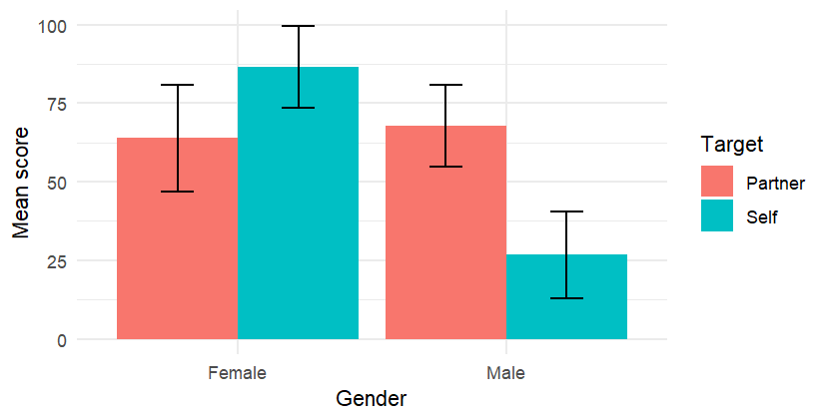
      - R code
# INFIDELITY
# Import Data
data <- read.csv("Infidelity.csv")

# Combine "Partner" and "Self" into "Target"
library(tidyr)
data_long <- tidyr::gather(data, Target, Score, -Gender,-X)

# Calculate Mean and Std. of "Gender" and "Target"
library(dplyr)
summary_data <- data_long %>% #input "data_long"
group_by(Gender, Target) %>% #grouping
summarise(mean = mean(Score), sd = sd(Score))

# Plot
# dodge:The bars representing different types will be displayed side by side.

library(ggplot2)
p <- ggplot(summary_data, aes(x = Gender, y = mean, fill = Target)) +
geom_bar(stat = "identity", position = "dodge") +
geom_errorbar(aes(ymin = mean - sd, ymax = mean + sd),
position = position_dodge(width = 0.9),
width = 0.25,
size = 0.7) + #outlook of error bar
labs(x = "Gender", y = "Mean score", fill = "Target") +
theme_minimal() #make pic clear

print(p)

- BOOK PUBLISHER
  - Plot the happiness level corresponding to the two publishers.
Using bar charts with error bars, I compared the popularity of two books and found that the average popularity of "women" is slightly higher than that of "statbook". The outliers for "women" are slightly higher than those for "statbook". However, this does not prove any statistically significant difference.

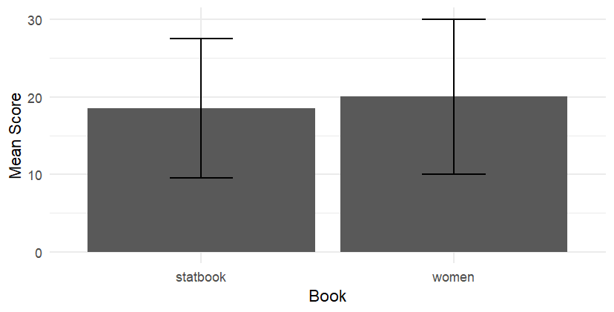
      - R code
# BOOK PUBLISHER
# Import Data
data_03 <- read.table("FieldBook.dat", header = TRUE, sep = "\t")

# Presentation of Data Organization
library(tidyr)
data_03_long <- tidyr::gather(data_03, Book, Score)

library(dplyr)
summary_data_03 <- data_03_long %>%
group_by(Book) %>%
summarise(mean = mean(Score), sd = sd(Score))

# Plot the happiness level
library(ggplot2)
p <- ggplot(summary_data_03, aes(x = Book, y = mean)) +
geom_bar(stat = "identity", position = "dodge") +
geom_errorbar(aes(ymin = mean - sd, ymax = mean + sd),
position = position_dodge(width = 0.9),
width = 0.25,
size = 0.7) + #outlook of error bar
labs(x = "Book", y = "Mean Score") +
theme_minimal() #make pic clear
print(p)
  - Perform the appropriate t-test on the comparison and report the effect size.
    - Setting null/alternative hypotheses.
  - Null Hypotheses: “women” - “statbook” <= 0
  - Alternative Hypotheses: “women” - “statbook” > 0

    - Explore the data: check distributional assumptions.

    - Compute the paired test.
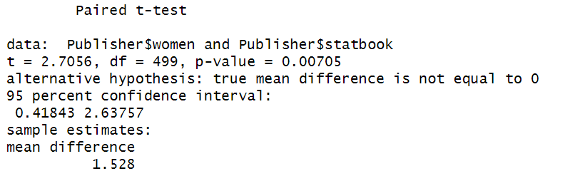

    - Calculate the effect size.
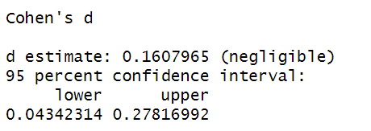

    - Report the test results.
The result of the paired t-test (p-value = 0.00705) indicates that reading "women" brings more happiness compared to reading "statbook".

      - R code
library("tidyverse")
library("rstatix")
library("effsize")
library("ggplot2")
library("ggpubr")
# 1. Data preparation
Publisher <- read.delim("FieldBook.dat")
Publisher <- Publisher %>% mutate(diff=women-statbook)

# 2. Explore the data: check distributional assumptions
pastecs::stat.desc(Publisher$diff, basic = FALSE, desc = FALSE, norm = TRUE)

# 3.Compute the paired test
(Paired.test <- t.test(Publisher$women, Publisher$statbook, paired = TRUE))

# 4. Calculate the effect size.
effsize::cohen.d(Publisher$women, Publisher$statbook, paired=TRUE)

